A synopsis on

**SMART DISINFECTION AND SANITATION TUNNEL**

Under the guidance (mentor) of

Aishwarya Saxena

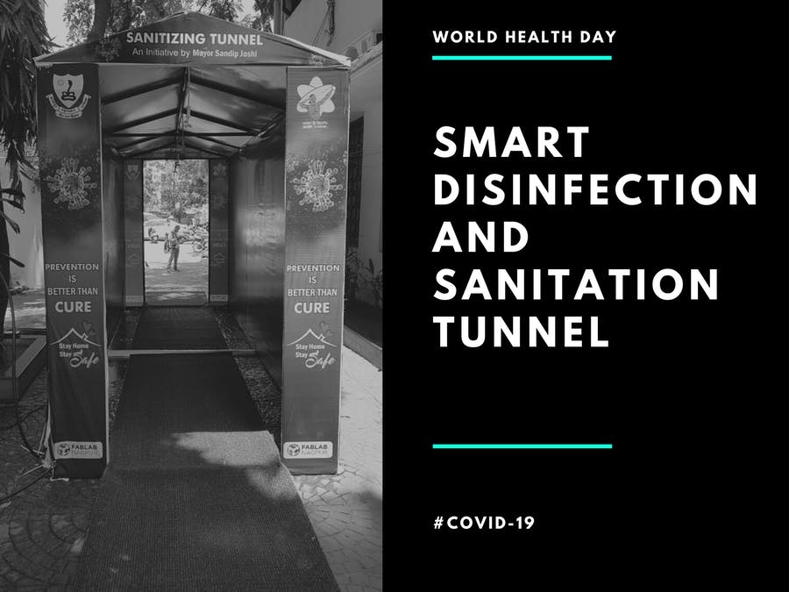

By- ● KRITI

●ROHINI SINGH

●ABHISHEK KUMAR

●ABHISHEK KUMAR

Machine Learning-Python

**SMART DISINFECTION AND SANITATION TUNNEL**

**INTRODUCTION**

The Smart Disinfection and Sanitation Tunnel is a demonstration of how It has been designed to provide maximum protection to people passing through the tunnel in around 15 seconds. Which can help the community to fight against the COVID-19.

The main idea of this project is to make a tunnel that can try and prevent the spread of COVID-19.

This disinfection and sanitation tunnel is prepared in order to sanitize people within 15 seconds from any possible bacteria.

The disinfectant solution used consists of a combination of sodium hypochlorite (NaOCl) and water (H2O). The disinfectant is non-volatile, thus enabling prolonged veridical and bactericidal activity and sanitizing the surfaces.

So, I took this initiative to make this Smart Disinfection and Sanitation Tunnel. This tunnel was made in a time span of 12hrs. It can disinfect a person fully from head to toe in a time span of just 15 seconds and the solution used is completely harmless*

**OBJECTIVE**

1. Disinfection tunnels can be static, where users stand in the middle of the tunnel and rotate while disinfectant is sprayed in their direction or dynamic, where the user’s path is prayed as they moved through the tunnel.
2. There is no way to test the benefits, other than mental satisfaction, which is just like confidence wearing a cloth mask provides and thereby enables people to venture out into public places.
3. Disinfection tunnel: potentially counterproductive in the context of a prolonged pandemic of COVID-19.

### 

### BACKGROUND

### A 1HP Water Pump machine is placed on the side of each tunnel that takes the solution of Sodium hypochlorite solution in water from the tank.The machine is automatic it senses whether anyone is entering into the tunnel. As anyone enters into the tunnel the Water Pump gets started for 15 seconds. So that the user can pass through that tunnel and if there is no one in the tunnel the pump will be off to save the water and electricity.The misty disinfectant spray protects citizens from catching bacteria for a period of at least 60 minutes. As it disinfects the air, exposed skin, and human clothing.

### Architecture

### 

### HARDWARE AND SOFTWARE REQUIREMENT

### Arduino UNO

### Jumper wires (generic)

### PIR Motion Sensor (generic)

### 12V Power Relay (4PDT)

### 12 Volt SMPS

### Channel SPDT Relay

### SeeedGroveToggle Switch, (On)-Off-(On)

### Toggle Switch, (On)-Off-(On)

### Raspberry Pi 3 Model B Raspberry Pi Camera Module V2

### Micro SD card

### Micro-USB to USB Cable (Generic)

### Micro-USB to USB Cable (Generic)

### Heat sink

### 1 HP Water Pump

### Steel Box Pipe

### Water Tank (200 L)

### PVC Plastic Pipe

### 4-Way Fogger

### Banner FlexTee Joint

### Micro Tubing Pipe

### Wall Fix lamp

### Elbow

### Cable Tie, Double Sided

### Cable Tie, Double Sided

### Software apps and online services

### Arduino IDE

### Arduino IDE

### Raspbian

### Raspberry Pi Raspbian

### OpenCV

### FUTURE SCOPE

### The presented smart tunnel can prevent or disinfect an outsider who is entering a particular building or a premise from COVID-19 infection possibilities within 10 s.

### The presented smart epidemic tunnel can function using solar energy during the day, and it functions using a solar power bank at the night time.

### This functionality has been provided by an LDR sensing unit placed in a tunnel.

### Furthermore, the tunnel has been designed in such a way that it can also disinfect a disabled person sitting in a wheelchair or a person riding a bike.

### In the end, Web and mobile interface has been designed to provide daily, weekly and monthly reports of the counts of individuals, along with in-out timestamps and power usage reports. In the future, an AI-based tunnel can be designed which can detect face-masks and provide auto-thermal scanning of the individuals to protect them from coronavirus-like infections.

### CONCLUSION

### In the undertaken study, an IoT-based sensor fusion assistive framework has been proposed to do real-time detection of individuals from a distance of 1.5 m. The presented smart epidemic tunnel starts functioning when a human id detected by an ultrasonic sensing unit equipped in a tunnel. After an individual is detected, the nozzles placed in a tunnel spray a sanitizer solution (made up from a mist of sodium hypochlorite) to disinfect an individual who has entered the tunnel. Sodium hypochlorite is a widely used component of bleaches in a variety of cleaning solutions such as water purification systems. The presented system has been designed as per the requirement of Symbiosis Institute of Technology, Pune. The presented smart epidemic tunnel has been designed from portable structures, which are made up of PVC and steel materials.

### REFERENCES AND BIBLIOGRAPHY

# **Bibliography**

# <https://www.hackster.io/yugn27/smart-disinfection-and-sanitation-tunnel-aefe50>

<https://www.healtheuropa.eu/smart-disinfection-technology-in-the-spotlight/101906/>

<https://github.com/yugn27/Smart-Disinfection-and-Sanitation-Tunnel>